You are required to create a Django project named cricketproject that includes one app named cricket. The project should meet the following specifications:
1. Home Page (URL: 127.0.0.1:8000/)
The home page of the website should have 2 links named:
➢ HOME ABOUT
When you click on the HOME link, it should redirect you to the Home page.
The page should display the heading:
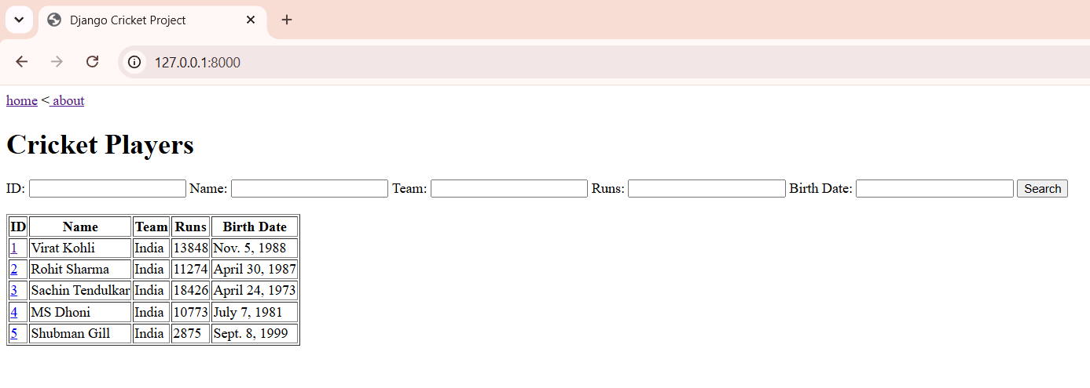
Cricket Players
The page should contain a search form with the following fields:
➢ ID
➢ Name
➢ Team
➢ Runs
➢ Birth Date
A Search button should be provided.
The page should display a table containing player records from the database with the following columns:
| ID | Name | Team | Runs | Birth Date |
The data for this table should be extracted from the database stored in the Django Admin interface.
The search operation must be performed using icontains.
If multiple search fields are entered, records should be filtered using AND condition.
When you click on any Player ID, it should open the corresponding player detail page.
Example:
If you click on ID = 3, the URL should be:
127.0.0.1:8000/info/3/

2. About Page (URL: 127.0.0.1:8000/about/)
When you click on the ABOUT link, it should redirect you to a page displaying:about page
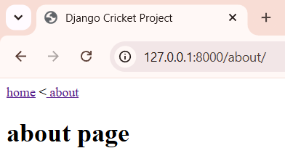

3. Player Detail Page (URL: 127.0.0.1:8000/info//)
When you click on any Player ID from the Home page, it should redirect you to a page displaying complete information of the selected player.
The page should display the following details:
➢ ID,➢ Name,➢ Team,➢ Description,➢ Profile URL,➢ Runs,➢ Birth Date,➢ Created At
A Back link should be provided to return to the Home page.
Example:
If you click on Player ID = 3, the URL should be:127.0.0.1:8000/info/3/
and complete details of that player should be displayed.
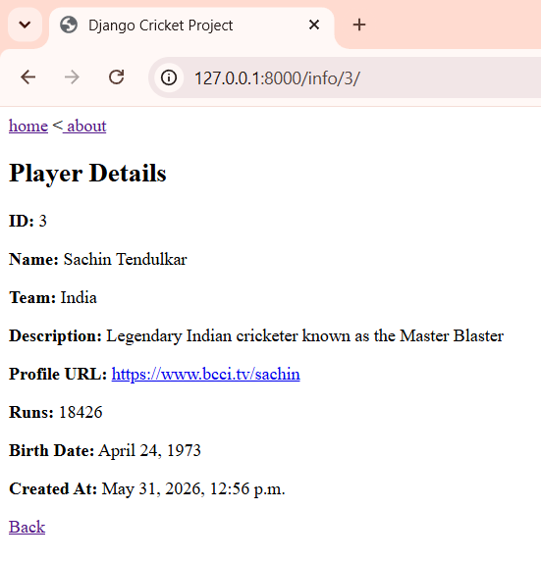
Database Requirements
Create a model named Player with the following fields:
Field Name | Data Type
player_name | CharField
team_name | CharField
description | TextField
profile_url | URLField
runs | IntegerField
birth_date | DateField
created_at | DateTimeField
Register the model in the Django Admin panel.
Enter at least 5 player records through Django Admin.

URL Requirements
Create the following URL patterns exactly:
Home Page:127.0.0.1:8000/
About Page:127.0.0.1:8000/about/
Player Detail Page: 127.0.0.1:8000/info//
Search Test
If the following values are entered: Name = s Runs = 18426
Only the record of Sachin Tendulkar should be displayed because both conditions must be satisfied.
